KLB: Notice of change in stamp specimen, position and sample signature of person who has the right of General Manager and Legal representative
On 24 Feb 2018, Kien Long Commercial Joint Stock Bank announced Notice of change in stamp specimen, position and sample signature of person who has the right of General Manager and Legal representative
Kien Long Commercial Joint Stock Bank would like to announce stamp specimen, position and sample signature of Ms. Tran Tuan Anh – the person who has the right of General Manager cum Legal representative of Kien Long Commercial Joint Stock Bank to agencies, departments, credit institutions, economic organizations and units under Kien Long Commercial Joint Stock Bank
- Stamp specimen of Kien Long Commercial Joint Stock Bank:
Stamp specimen No. 01 | Stamp specimen No. 02
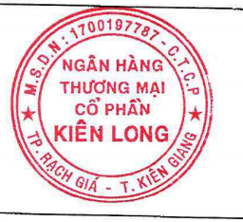 | 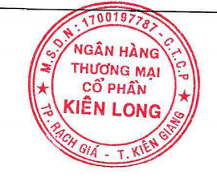
- Sample signature of Ms. Tran Tuan Anh – person who has the right of General Manager:
Sample signature No. 01 | Sample signature No. 02
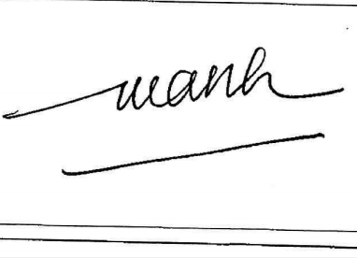 | 